NAME: | Aravala Tirupathi Venkata Jathin Kumar
ID: | 2400031734
SECTION: | S-22
SUBJECT: | FULL STACK APPLICATION  DEVELOPMENT

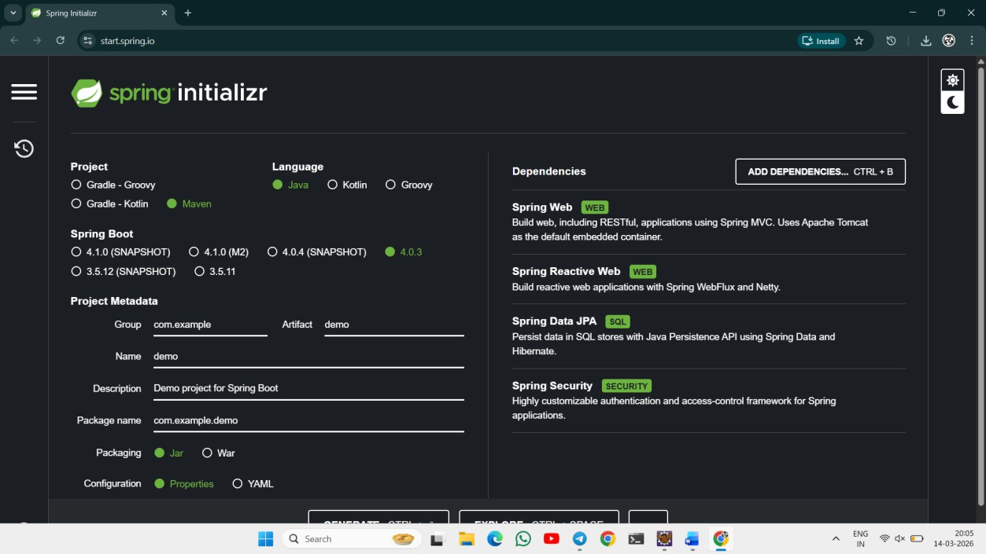

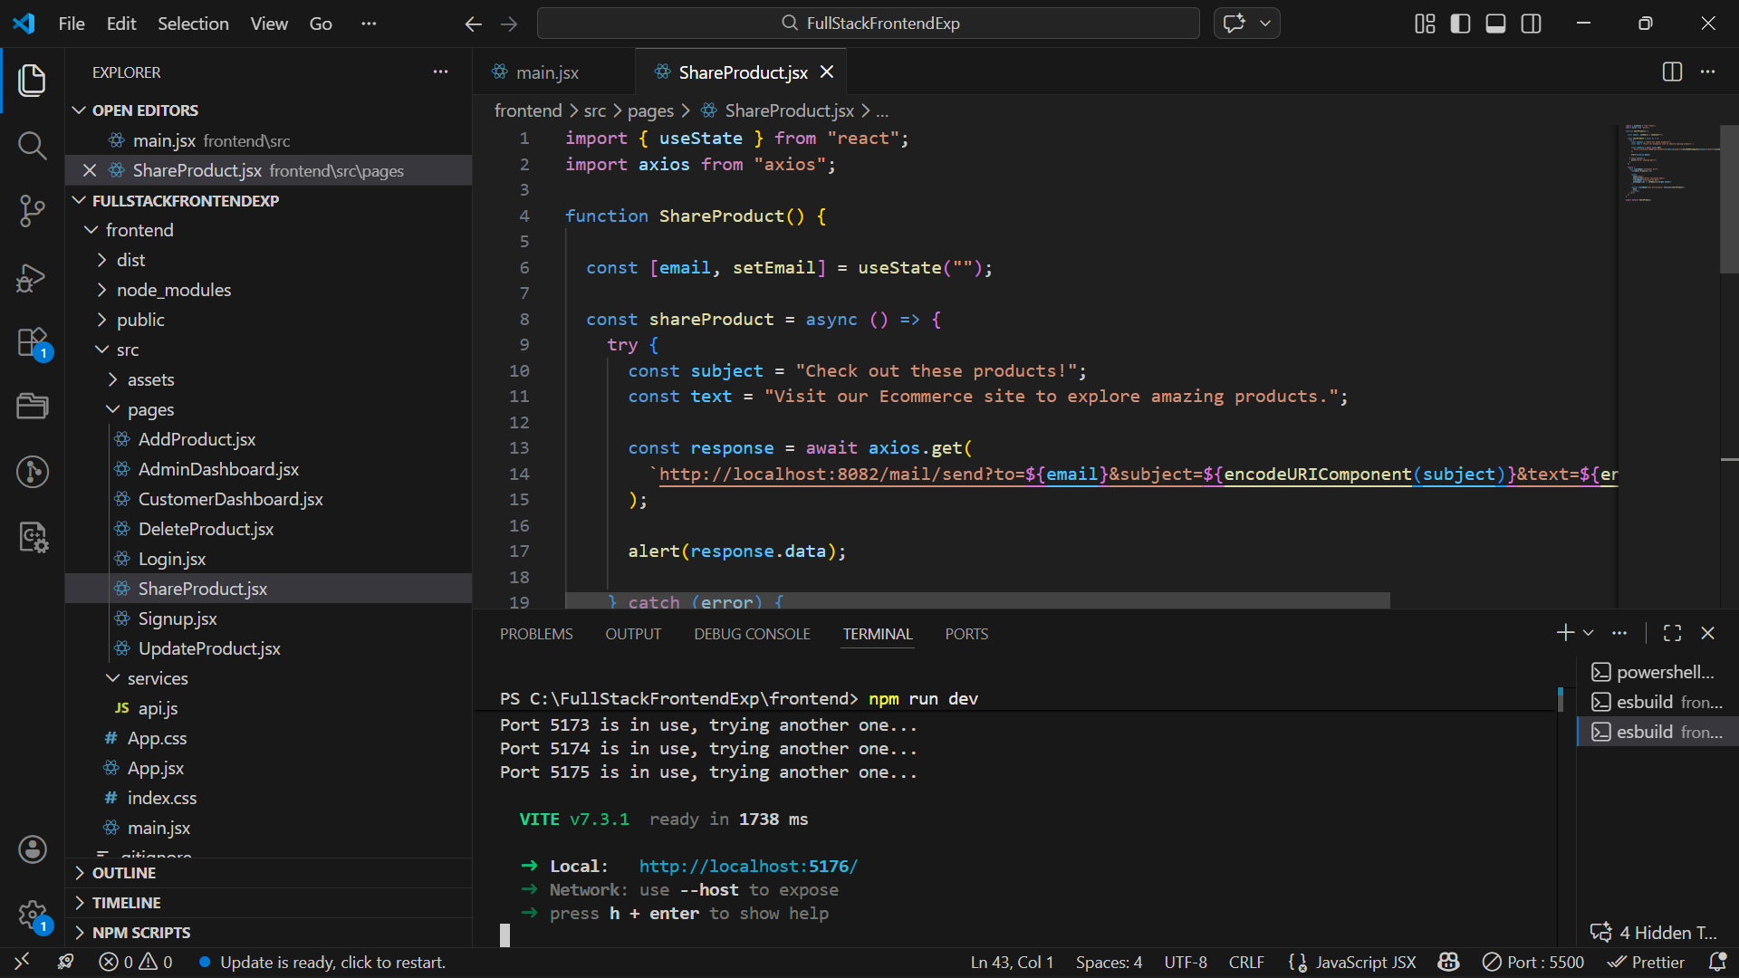

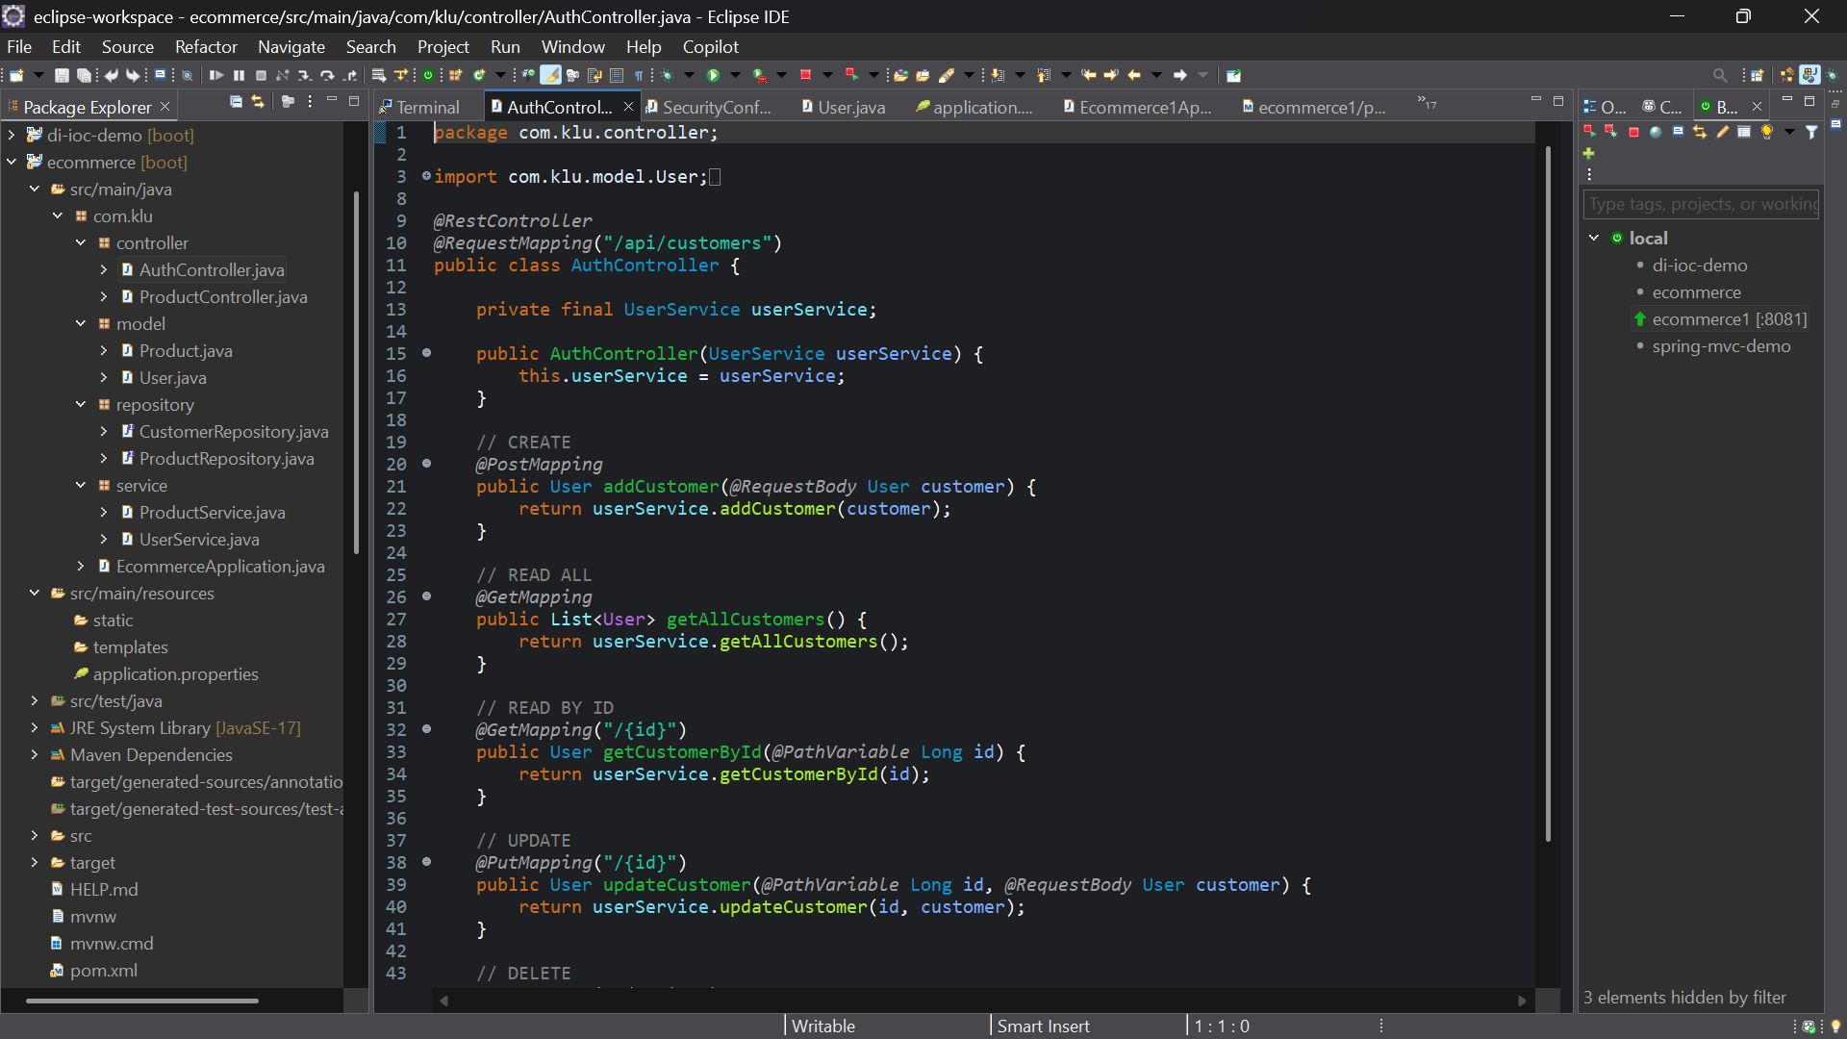

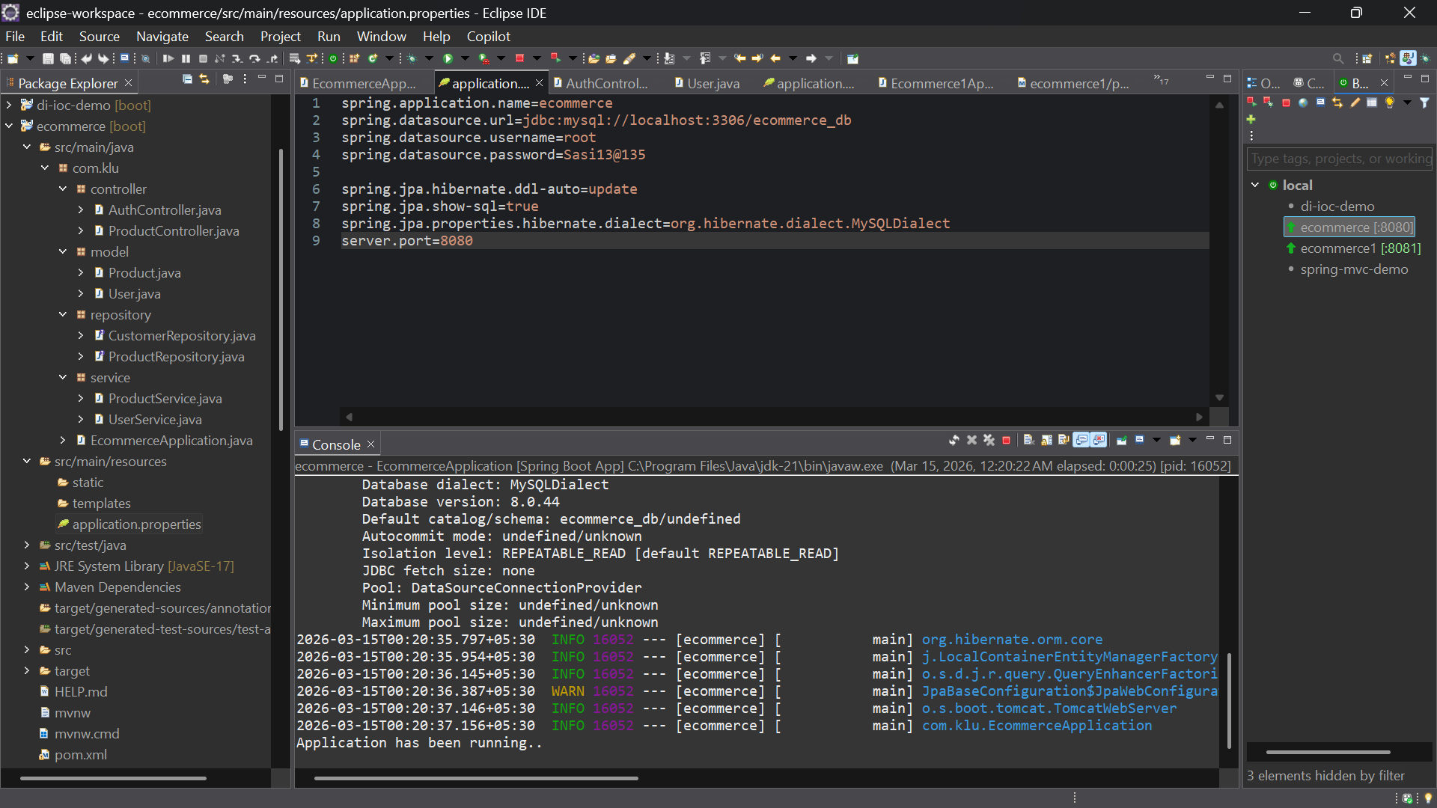

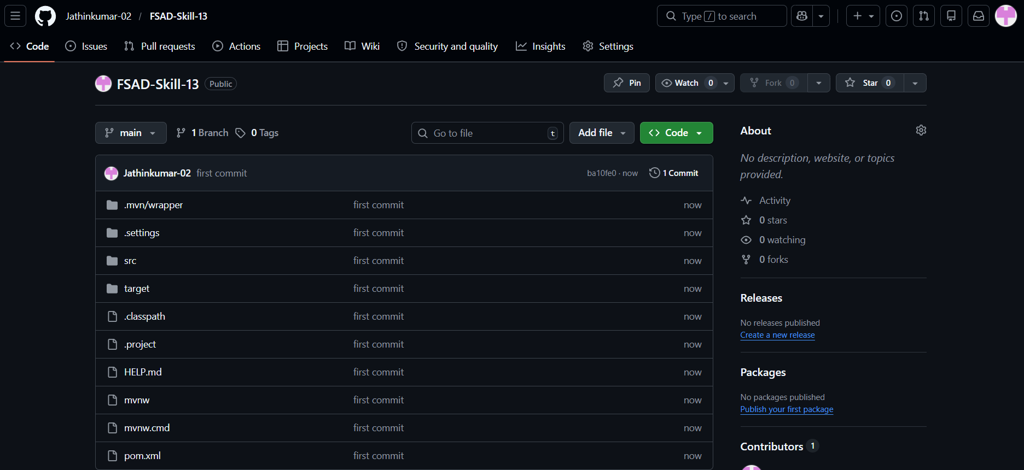

GIT HUB LINK: Jathinkumar-02/FSAD-Skill-13

